Task 3

Создать таблицу с количеством использования функций, используя data_for_merge.csv, заполнить ее через **оператор merge.** Итоговая таблица с результатами должна иметь вид

|  |  |
| --- | --- |
| Function_name | Function_count |
| CASE | 4 |
| CAST | 2 |
| CONCAT | 7 |

SELECT DISTINCT Function_name , COUNT (Function_name) AS Function_count

FROM

(SELECT Alex, Carlos, Charles, Daniel, Esteban, Fred, George, Lando, Lewis

FROM [dbo].[data_for_merge]) p

UNPIVOT

(Function_name FOR Employee IN (Alex, Carlos, Charles, Daniel, Esteban, Fred, George, Lando, Lewis)

) AS UNPIV

GROUP BY Function_name;

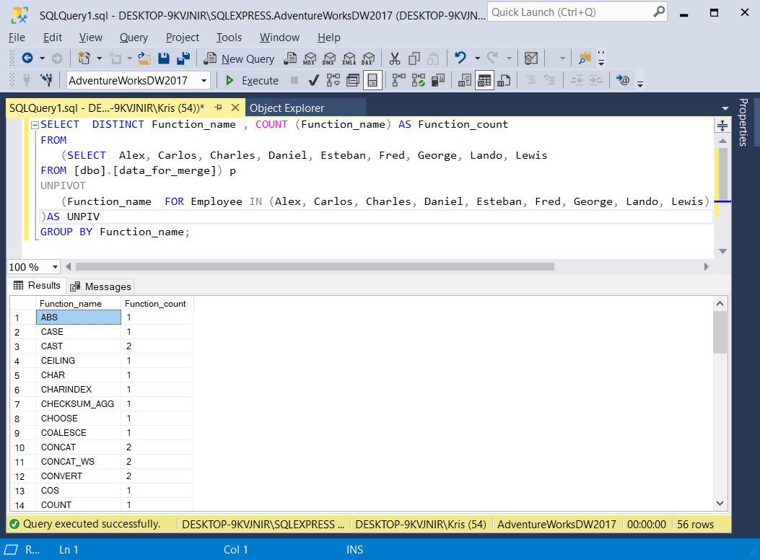

CREATE TABLE Functions_number

(

Function_name nvarchar(50),

Function_count int

);

MERGE Functions_number target

USING

(SELECT Function_name, COUNT(Function_name) AS Function_count

FROM

(SELECT Function_name, Name

FROM

(SELECT Alex, Carlos, Charles, Daniel, Esteban, Fred, George, Lando, Lewis FROM [dbo].[data_for_merge]) AS NAME_dfm

UNPIVOT

(Function_name FOR Name IN (Alex, Carlos, Charles, Daniel, Esteban, Fred, George, Lando, Lewis)) AS UN_NAME

) AS UNPVT

GROUP BY Function_name

) source

ON target.Function_name = source.Function_name

WHEN MATCHED

THEN UPDATE SET target.Function_name = source.Function_name,

target.Function_count = source.Function_count

WHEN NOT MATCHED BY TARGET

THEN INSERT (Function_name, Function_count)

VALUES (source.Function_name, source.Function_count)

;

select *

from Functions_number;

